Light Weight Rules Engine

Background, Purpose and Scope
In most business oriented software applications business management collects data in order to facilitate the sale of a product or service. Insurance and financial products unlike most retail products or services frequently require the purchaser to prequalify for the purchase. Prequalification requires the purchaser to present information that will be validated against concrete criteria based on the product or service offered. These criteria become the business rules that must be tested as part of the data collection process.

As business software patterns have evolved, software architects have realized that many of the methodologies that provide validation of criteria for the business to operate have structures that are inflexible and unwieldy. This is due in part to customer expectations relative to product processing and the lack of consideration by all parties to provide a flexible, scalable methodology to incorporate business rules in a software application.

Admittedly there are several ways of creating a rules engine and there are several products on the market that will accomplish the requirements out of the box. Microsoft BizTalk and the new rules engine provided with Microsoft Windows Workflow Foundation (WF). At this engagement, the costs associated with BizTalk make that solution unworkable and the new rules engine associated with WF came out after this methodology was in development.

The purpose of this document is to describe a combination of technologies that when used together create a flexible, database driven business rule validation engine. This engine when used will allow business rules to be defined based on the product or service to be provided. These business rules are configurable within the database structure which reduces the need for extensive regression testing and allows additional rules to be added without recompiling the engine components.

Although the sample code is provided using Visual C# and the .NET Framework 3.5, the concepts here apply to Visual Basic, Java and C++

Technologies Used

Several technologies have been incorporated in this rules engine to make it more flexible and scalable.

- Reflection – We use Reflection so that we can instantiate objects based on data coming from a database without the need to code within the rules engine the various rules to be implemented. Reflection allows the rules engine to add rules without recompiling and leads to less extensive regression testing

- Factory Pattern – The factory pattern as seen in figure 1 provides encapsulated operations precluding the consuming client from knowing the implementation details but ensuring the appropriate actions occur. An additional benefit is the consistency the factory pattern provides between products and services. The Factory Pattern will be discussed in more detail later in this paper.
- Chain of Responsibility Pattern – The Chain of Responsibility Pattern is the basic pattern to be used in any sequential validation schema. It provides for successive actions to be taken to validate incoming data and may work on a Pass/Fail or Pass/Fail/Catastrophic schema. The Chain of Responsibility Pattern will be discussed in more detail later in this paper.
- LINQ to Objects – LINQ to Objects is a set of classes incorporated in the .NET Framework 3.5 that eases the search and extraction of data from List objects and Datasets.
- LINQ to Xml -- LINQ to Xml is a set of classes incorporated in the .NET Framework 3.5 that eases the creation and parsing of Xml documents.

Factory Pattern
The Factory Pattern as described by the Gang of Four provides a means to implement functionality with a consistent methodology using any of several concrete factories. The client makes a call to a given Abstract Factory and in the call identifies the concrete factory it wished to implement. Based on that input from the client the abstract factory instantiates the concrete factory and hides the actual implementation.

A demo project is available in the solution provided. Hardware and software requirements and installation instructions are provided in the Appendix.

The factory pattern demo project contains two separate factory patterns. The first uses the standard methodology of a switch structure in the abstract factory to control the creation of the concrete factories. The second uses reflection to do the same thing. This will give you a picture of how reflection gives you more flexibility than the standard switch.

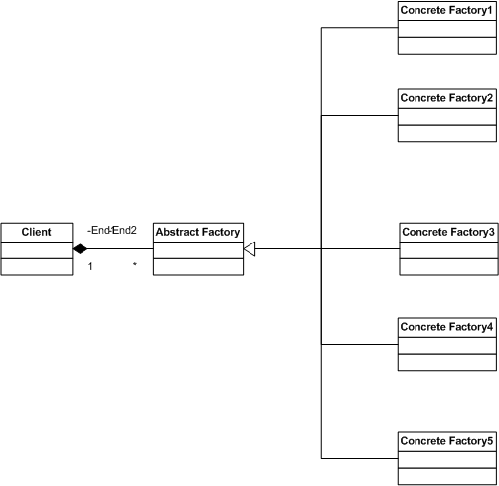
Figure 1
Figure 2 shows the code of a standard abstract factory using a switch. Figure 3 shows the same type of abstract factory using reflection. The abstract factory could add additional concrete factories without the need to recompile because

public abstract class WidgetFactory
{
public WidgetFactory() { }
public static WidgetFactory GetConcreteFactory(string ConcreteFactory)
{
WidgetFactory wf = null;
switch (ConcreteFactory)
{
case "GreenWidget":
wf = new GreenWidget();
break;
case "BlueWidget":
wf = new BlueWidget();
break;
case "RedWidget":
wf = new RedWidget();
break;

}
return wf;
}
}

Figure 2

public abstract class WidgetFactory2
{
public WidgetFactory2() { }
public static WidgetFactory2 GetConcreteFactory(string ConcreteFactory)
{
Assembly oAssembly = Assembly.Load("FactoryPattern");
WidgetFactory2 wf = (WidgetFactory2)oAssembly.CreateInstance(ConcreteFactory);
return wf;
}
}

Figure 3

You can set the Factory Pattern project as your startup project and step through the code in debug mode and see the differences between the two forms.

Chain of Responsibility Pattern
The Chain of Responsibility pattern provides a means to select in advance successive actions in the case of one test or another. In most Chain of Responsibility pattern classes you have many of the same types of components as the Factory pattern. What makes the COR pattern effective is the selection of the successor actions to be taken. The Handler is again an abstract class. Figure 4 shows the class diagram It has two methods: SetSuccessor and HandleRequest. SetSuccessor is a straight forward method use to set a property. HandleRequest does the real work. Figure 5 shows the HandleRequest method.

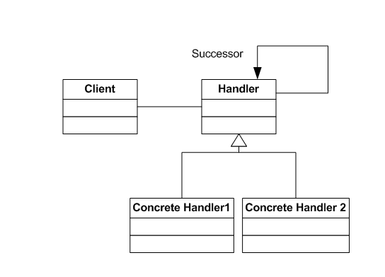

Figure 4

public override void HandleRequest(int request)
{
if (request >= 0 && request < 10)
{

Console.WriteLine("{0} handled request {1}",
this.GetType().Name, request);
}

else if (successor != null)
{
successor.HandleRequest(request);
}
}

Figure 5

As you can see if the initial if statement is true, the action is completed and the method finishes. Otherwise, the method passes the original request data to its successor class. In the Demo Solution set the Chain of Responsibility project as the startup project and step through it in debug mode.

Rule Classes
In a database driven rules engine the rules must be defined as separate classes. They may be placed in a common assembly for each rule in its own assembly. The rule class will take the form of the Concrete Handler in the Chain of Responsibility Pattern.

Rule Engine Database
The Rule Engine database contains all the tables to run the application. See Figure 6.

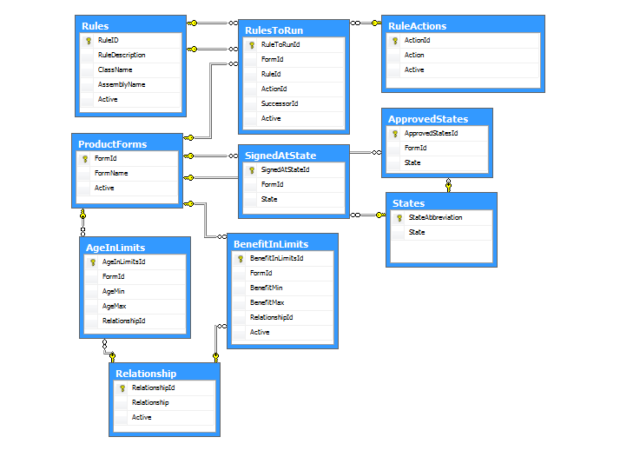
Figure 6

The Rules table provides a list of available rules with its Class and Assembly names for the reflection components to use.

The RulesToRun table identifies which rules are to be run for a given product or service.

The RuleActions table identifies the possible outcomes for a given rule. In this application they are Pass, Fail, Catastrophic and Done.

The ProductForms table lists the products available for the rules engine to validate.
ApprovedStates, SignedAtState, BenefitInLimits, and AgeInLimits are custom rules tables associated with specific and individual Rules. Each of the custom rules have tests for Catastrophic failure and Pass/Fail.

Relationship and States are tables used as constraints for the custom rules tables.

Sample Application
The sample application has defined insurance products that must have certain criteria tested. For example, the age of the participant must be within certain limits, the state of application must be an approved state, the application must be signed within a set of given states and benefits must fit within a given range. We have in the sample application three different products each has its own set of rules. The products do not have the same criteria.

Sample Application – Insurance Products
- Group Life Policy
  - Form Number 1375
  - Age in Limits
    - Adult 21-61
    - Child 0 – 23
  - Approved State
  - List In Database
  - Signed At State
    - Application Signed in Approved State
    - FL, GA, IL, NC, SC
  - Benefit Limit
    - Adult 10K-100K
    - Child 10K – 10K
- Individual Life Policy
  - Form Number 1661
  - Age in Limits
    - Adult 21-61
    - Child 0 – 21
  - Signed At State
    - Application Signed in Approved State
    - AL, GA, NC, SC
  - Benefit Limit
    - Adult 20K-200K
    - Child 20K – 20K
- Family Life Policy
  - Form Number 1662
  - Approved State
    - List In Database
  - Signed At State
    - Application Signed in Approved State
    - FL, GA, IL, NC, SC
  - Benefit Limit
    - Adult 10K-100K
    - Child 10K – 10K

Product Purchase Applications
Product purchase applications take the form of Xml documents and are found in the XmlDocuments folder in the LightWeightRulesEngine project. There are six 1375 applications, five 1661 applications and five 1662 applications. The Xml for the demonstration products takes the same form. See Figure 7.

<Applications>
<Application AppId="1">
<FormId>1375</FormId>
<FirstName>Joseph</FirstName>
<LastName>Jones</LastName>
<Address1>123 East Main Street</Address1>
<Address2>Apt 2</Address2>
<City>Chicago</City>
<State>IL</State>
<Zipcode>60652</Zipcode>
<Telephone1>312-555-1213</Telephone1>
<Telephone2>312-556-1213</Telephone2>
<Birthdate>9/3/1960 12:00:00 AM</Birthdate>
<Benefit>10000</Benefit>
<SignedAtState>GA</SignedAtState>
<CWA>Yes</CWA>
<Relationship>1</Relationship>
</Application>
</Applications>

Figure 7.

Light Weight Rules Engine
The Light Weight Rules Engine is made up of classes associated with each of the tables in the database. Each class associated with a table is in fact two files; each making up a partial class. Using the Rules class as an example the Rules.cs file has this note at the beginning:

///
/// This class is generated from an automated application and is created based on
/// Database fields and their property types.
///
/// Modifying this file may result in problems interacting with your database table.
/// We recommend you do not modify this file but regenerate it from the database as needed.
///
/// This is a partial class so that you can create a second partial class that will contain all your
/// overloaded and custom code. This second partial class will not be modified by the class generator.
///

This is because the class is generated by a code generator from the database table itself. The class properties exactly match the fields in the Rules table in both name and data type. The second file, RulesCustom.cs contains the custom methods used to support the class. The reason for this structure is that in the event the table changes and the Rules class is regenerated from the code generator, the custom code will not be lost.

The Program.cs file does the primary work. Follow along with the code in the Main method in the Program.cs file. The first action is to populate the lists associated with the Rules Engine. These lists draw from the database and place into memory the details in the database on the products, rules, actions to take, etc. In this way there is only one pull from the database at the start of the application or service.

One of these lists is a list of files to process. This list could be generated as it is here or through a file watcher program. This is the list of items the application will test.

On each file in the list we will use LINQ to Xml to pull the FormId out of the Xml. The FormId will be used to determine the rules to apply for a give application. See Line 44 of the Main method. LINQ to Objects will draw the rule set from the Rules List. See Line 47 of the Main method. The next few lines of code provide the unique list of rules for the product based on the FormId.

The application then moves into a loop where the Rules Engine will process the application through the list of rules. And take to the output from the HandleRequest method in the RuleFactory to provide the result to the log. The abstract class RuleFactory has two methods: HandleRequest and GetNextRule. HandleRequest uses reflection to instantiate the concrete rule class and then runs the rule against the application. The GetNextRule determines the successor rule to be used.

The rest of the code is very straight forward. The solution is enclosed. The database is located in LightWeightRulesEngine\App_Data folder. The Xml files are in LightWeightRulesEngine\XmlDocuments.
Appendix 1
Demo Setup Instructions

Hardware Required:
1. PC Desktop, Laptop or Server.

Software Required:
- Microsoft Visual Studio 2008 or
- Microsoft Visual C# Express Edition
- Sql Server 2005 Express or
- Sql Server Standard

Setup Instructions:
- Extract the solution LightWeightRulesEngine from the .zip file.
- Open the app.config file and modify the connection string to the database. The database is located in the App_Data folder. You have several choices here: Use Sql Server Express edition and attach the file or move the database to Sql Server. If you need to attach the database to your instance of Sql Server Express, merely drag and drop the file icon from the Solution explorer to the app.config file.
- In Visual Studio Solution Explorer right click on the LightWeightRulesEngine and select it as the startup application
- Run the application.

